

**Faculty of engineering - Shoubra**

**Benha University**

**Research Article / Research Project / Literature Review**

in fulfillment of the requirements of

|  |  |
| --- | --- |
| **Department** | **Engineering Mathematics and Physics** |
| **Division** | **-----** |
| **Academic Year** | **2019/2020 preparatory** |
| **Course name** | **Computer** |
| **Course code** | **ECE001** |

**Title: -**

**artificial intelligence**

By:

|  |  |  |  |
| --- | --- | --- | --- |
|  | Name | Edu mail | B.N |
| 1 | Nourhan safwat yassin | nourhan196133@feng.bu.edu.eg | 1006 |

**Approved by:**

|  |  |
| --- | --- |
| Examiners committee | Signature |
|  |  |
|  |  |
|  |  |
|  |  |
|  |  |

**Application Brief**

Artificial intelligence is a science and technology based on disciplines such as Computer Science, Biology, Psychology, Linguistics, Mathematics, and Engineering. A major thrust of AI is in the development of computer functions associated with human intelligence, such as reasoning, learning and problem solving

Even though artificial intelligence evokes science fiction thoughts, artificial intelligence already has many uses today, such as:

* Banks use artificial intelligence to determine if there is strange activity on your account. Unexpected activity, such as foreign transactions, could be flagged by the algorithm.
* Email filtering: Email providers filter incoming emails using artificial intelligence
* Speech recognition: Applications use artificial intelligence to optimize speech recognition functions. Examples include intelligent personal assistants.

**Screenshots**

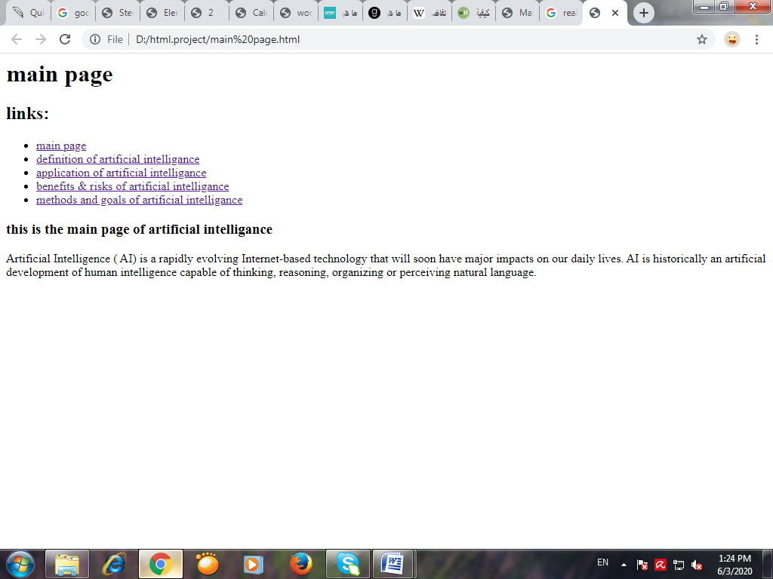

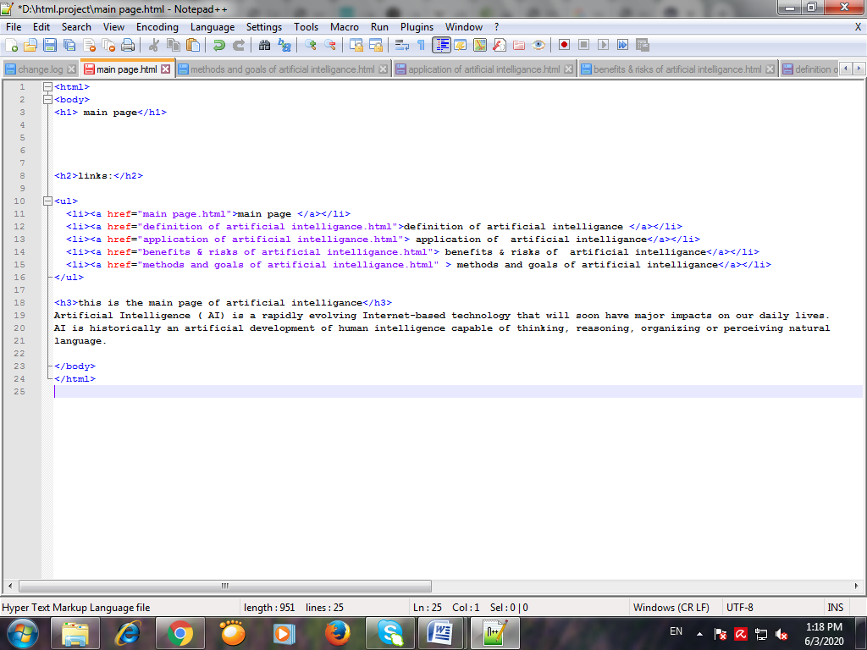Source code

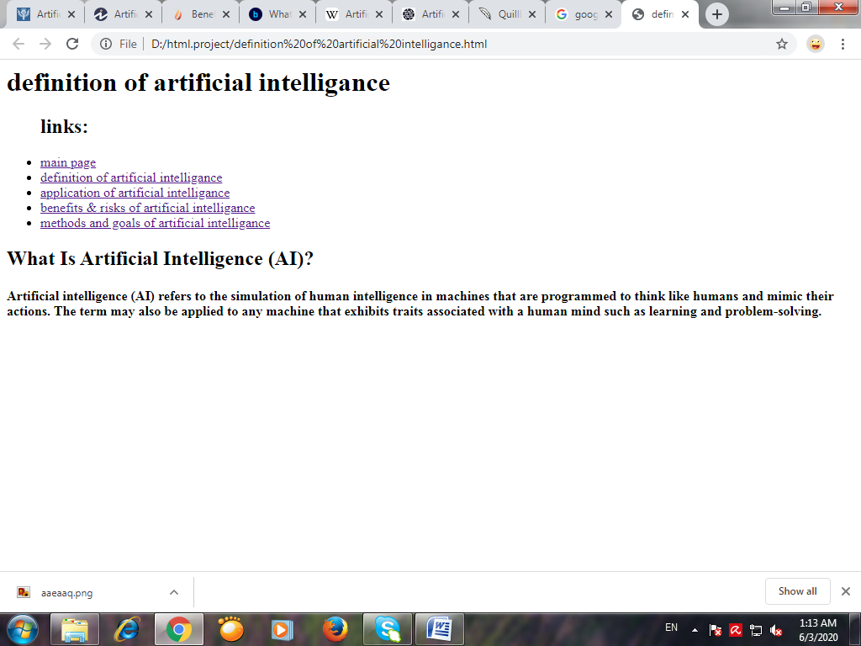

Source code

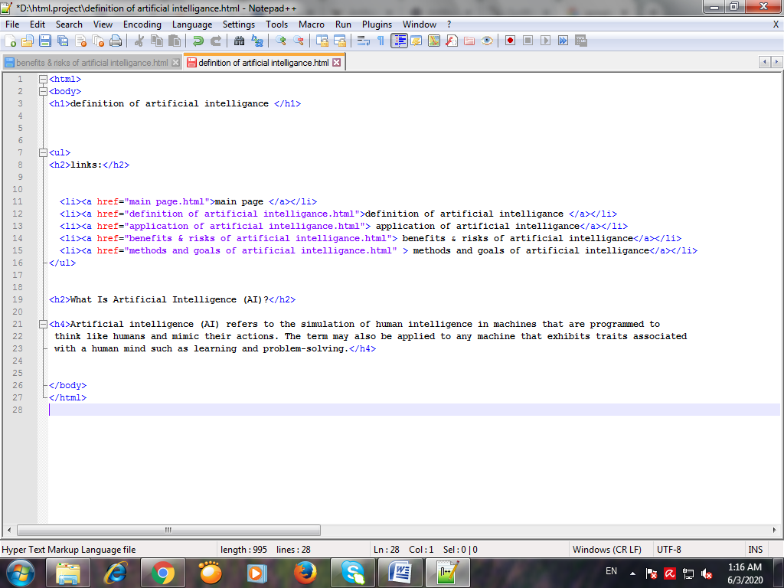

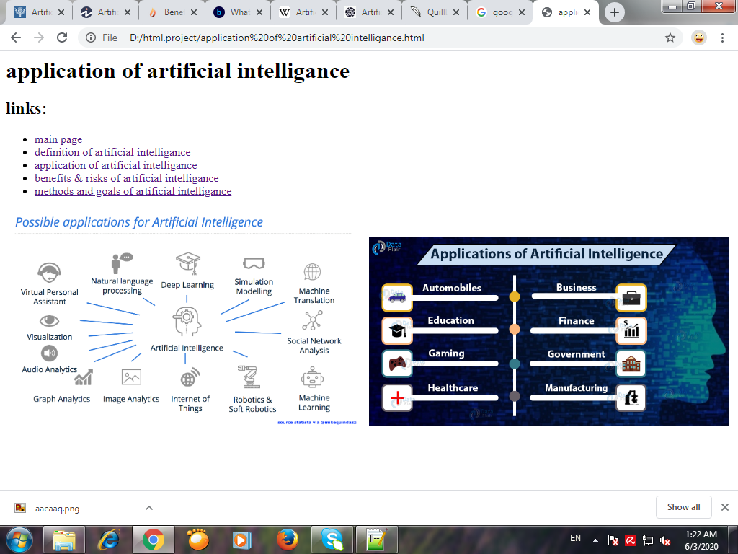

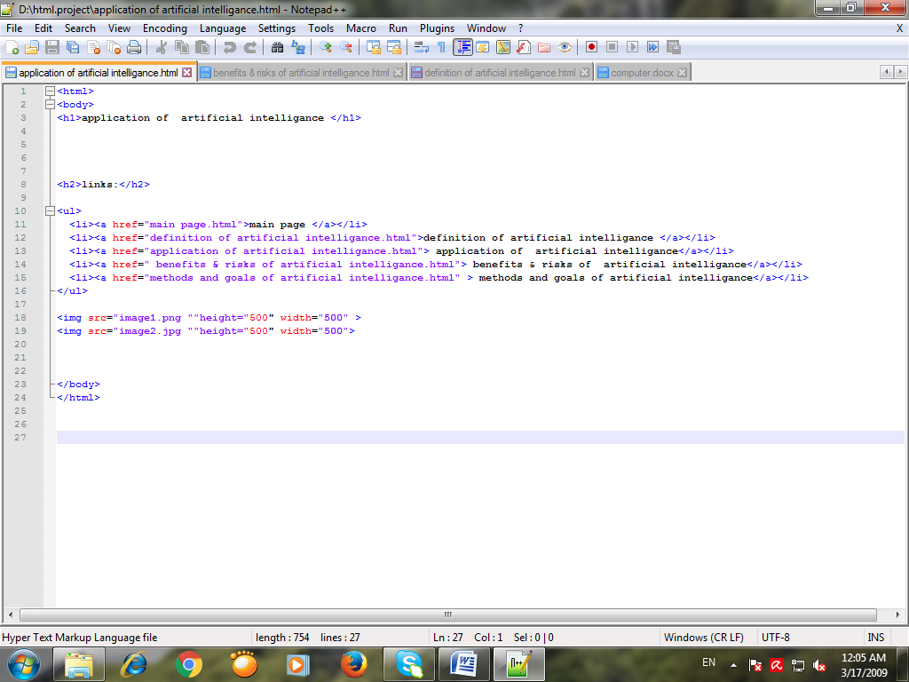Source code

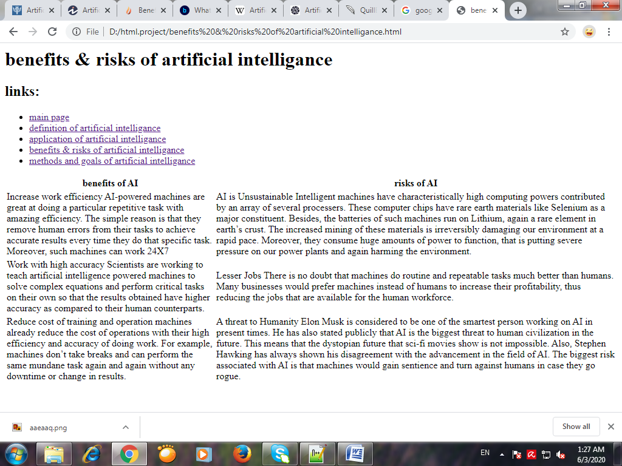

Source code

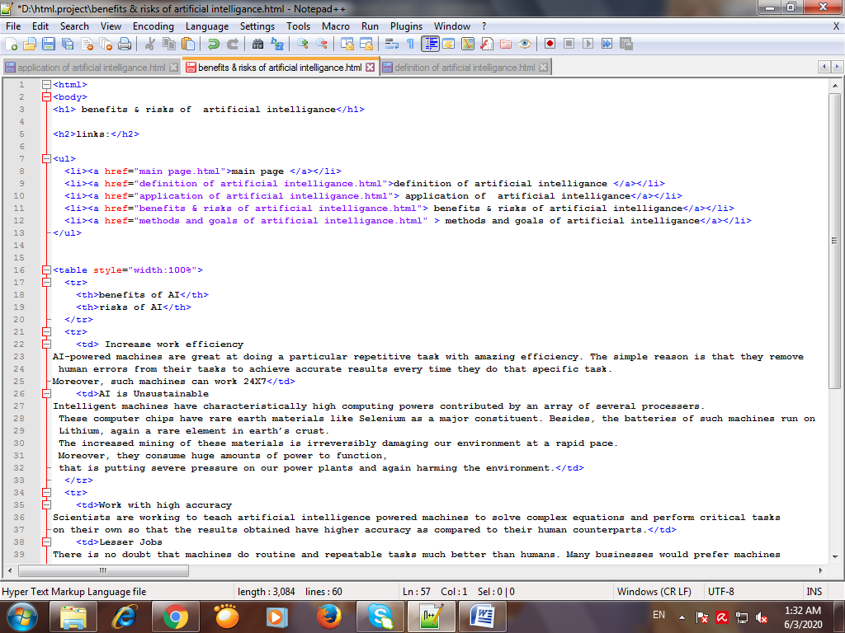

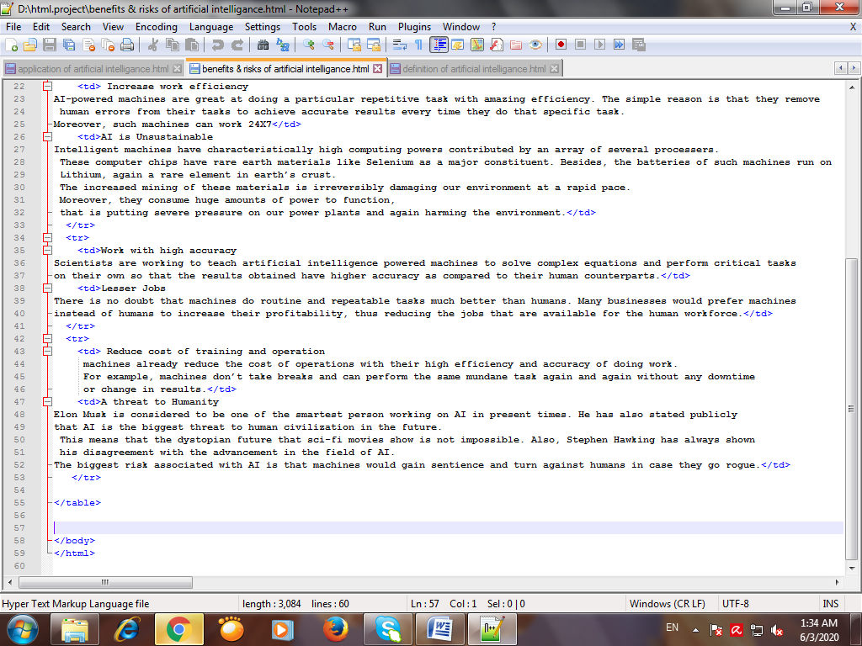

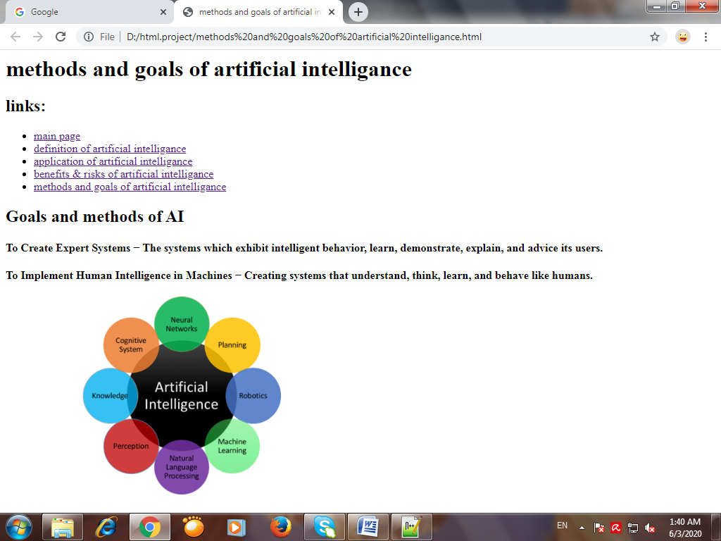

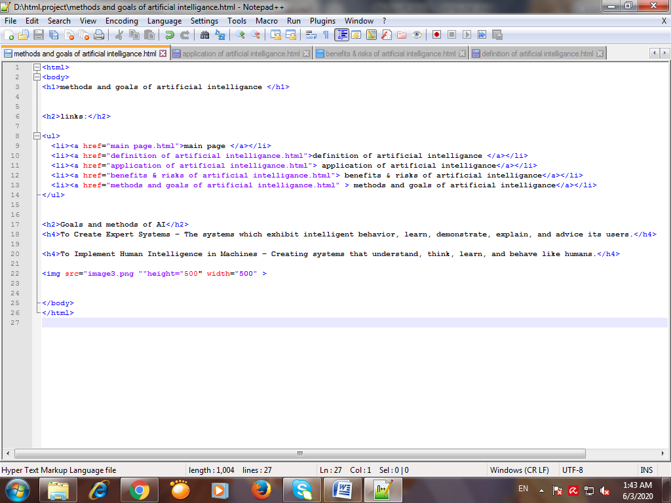Source code